**Activity Kit: Face Masks**

This tutorial will show you how to make your own face mask that you can sew by hand. Wearing this mask when out in public can help to slow the spread of disease and protect other people you come into contact with. It can be used as a protective face covering in situations where social distancing is difficult. Cloth face masks should be washed in a washing machine on high heat regularly to minimize the spread of disease.

**Disclaimer:** According to the CDC, Cloth face coverings are not surgical masks or respirators. Currently, those are critical supplies that should continue to be reserved for healthcare workers and other medical first responders, as recommended by current CDC guidance. Cloth face coverings provide an extra layer to help prevent the respiratory droplets from traveling in the air and onto other people.

**Objective:** Sewing skills, public safety

**Materials Included:**

* 1 10”x20” piece of cotton fabric
* 2 7” strips of sewing elastic
* Sewing thread
* Printed sewing pattern
* Sewing needles
* Safety pins
* Scissors

**You will need:**

* A pencil or piece of chalk
* An iron & ironing board (optional)

**Instructions:**

1. Start by cutting your paper face mask pattern along the solid black line
2. Fold your fabric into quarters so both edges meet in the middle, like this:

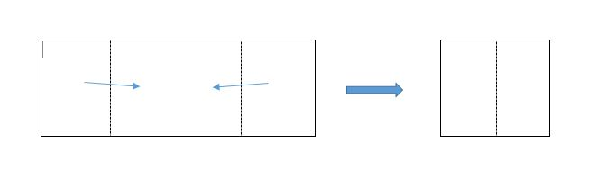

1. If you have an iron, you can iron your fabric on each fold so it lays flat.

**Instructions (continued):**

1. Place your paper pattern on one side of your folded fabric and trace the shape with a pencil or chalk. Use safety pins to secure both pieces of fabric around the pattern outline. Do the same for the other side of your fabric. Cut around both pattern outlines. You will end up with four pieces of fabric in the shape of your paper pattern.
2. Thread your needle with your sewing thread. Secure it with a double knot.
3. Place two pieces of your fabric patterns together, so that the right sides of the fabric face each other (right sides together). All edges of your fabric should be lined up with each other.
4. Take your needle and thread and hand-stitch along the curved edge of the fabric, ¼ inch from the edge of the fabric (¼ inch seam).
5. Repeat steps 6 & 7 for the remaining two pieces of fabric.
6. Once you’ve sewn both pieces, you can use your iron to press the seams of each piece open. You have sewn the front and back pieces of your face mask.
7. Now, place the front and back of your mask together with the right sides together. Secure them with safety pins if needed.
8. Use your needle and thread to stitch along the top and bottom edges of your fabric, with a ¼ inch seam.
9. Turn the mask right-side out through one of the open side seams and press with your iron.
10. Take both of the side edges of your mask and turn them to face the back of your mask, about ¼ of an inch from each edge. You can iron each edge on the fold or use your safety pins to secure each edge
11. Use your needle and thread to sew along each side, so each edge is sewn closed.
12. Now, you can attach the sewing elastic so the mask will fit behind your ears. If you are under the age of 7, you can cut your elastic 1-2 inches per piece.
13. Attach each piece of elastic at the sides of your mask with safety pins. Use your needle and thread to stich the elastic in place.

Congratulations! You have successfully made your own face mask. Be sure to wear it whenever you go out in public wash it regularly with hot water (in the washing machine). Stay safe!

**Follow up:**

You can post pictures of your homemade mask online!

If you use social media, you can take pictures of you seed ball as it grows and post them online. Tag @buildrepairgrow and #BRGfacemaskDIY to share your project!